1st Chapter
1/ Semiconductors and Properties of Semiconductor
Semiconductors are materials which have a conductivity between conductors and nonconductors or insulators. Semiconductors can be pure elements, such as silicon or germanium.
Properties of Semiconductor:
1.The resistivity of a semiconductor is less than an insulator but higher than a conductor.
2. Semiconductors show a negative temperature coefficient of resistance.
3. At zero kelvin, semiconductors behave as insulators. As the temperature is increased it works as a conductor
4. The conductivity of the semiconductors increases when impurities are added.

2/ Energy Band Theory
According to Bohr’s theory, every shell of an atom contains a discrete amount of energy at different levels. Energy band theory explains the interaction of electrons between the outermost shell. there are three different energy bands:
1. Valence band
2. Forbidden energy gap
3. Conduction band

3/ Classification of material according to energy band theory
Conductors: Gold, Aluminum, Silver, Copper, all these metals allow an electric current to flow through them. There is no forbidden gap between the valence band and conduction band which results in the overlapping of both the bands.

Insulators: Glass and wood are examples of the insulator. The energy gap in the insulator is very high up to 7eV.

Semiconductors: Germanium and Silicon are the most preferable material whose electrical properties lie in between semiconductors and insulators. For Germanium, the forbidden gap is 0.72eV and for Silicon, it is 1.1eV. Thus, semiconductor requires small conductivity.

4/ Classification of semiconductor
- Intrinsic Semiconductors: When impurity does not add to the pure semiconductor the it is said to be intrinsic semiconductor or pure semiconductor.

- Extrinsic Semiconductors: When impurity is added to the pure semiconductor the it is said to be intrinsic semiconductor.

5/ Formation of PN-junction
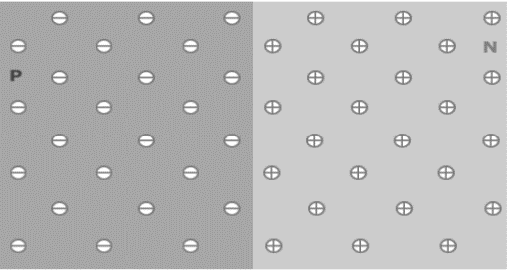
P-n junctions are formed by joining n-type and p-type semiconductor materials, as shown below. Since the n-type region has a high electron concentration and the p-type a high hole concentration, electrons diffuse from the n-type side to the p-type side. On the p-type side, negative ion cores are exposed. An electric field E forms between the positive ion cores in the n-type material. The animation below shows the formation of the E at the junction between n and p-type material.

6/ Properties and V-I Characteristics
- In forward bias condition p-type is connected to positive terminal of battery and the n-type
to the negative terminal of the battery.
- When the diode is in forward bias, as the voltage applied to the diode is overcoming the
potential barrier.

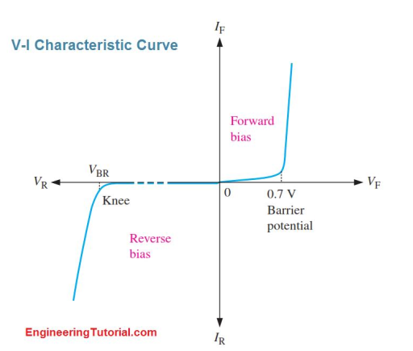

- When the PN junction diode is under reverse bias, this results in an increase in the potential
barrier and resistance also increases.

2nd Chapter
Definition, working principle and their application
1/ Light-emitting Diode (LED)
A light-emitting diode (LED) is a semiconductor device that emits light when an electric current flow through it.
Working Principle of LED
The working principle of the Light-emitting diode is based on the quantum theory. The quantum theory says that when the electron comes down from the higher energy level to the lower energy level then, the energy emits from the photon. If the PN-junction diode is in the forward biased, then the current flows through the diode.
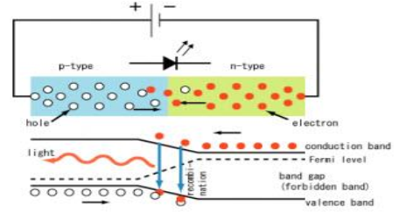

Eq = hf
Eq = he / λ

Application of Light Emitting Diode
- LEDs used for TV Backlighting
- It is used for Smartphone Backlighting
- Uses of LED in Displays
- These are used in Automotive
- LEDs used in Dimming of Lights

2/ Photodiode
A photodiode is a PN-junction diode that consumes light energy to produce an electric current. They are also called a photo-detector, a light detector, and a photo-sensor. Typical photodiode materials are Silicon, Germanium and Indium gallium arsenide.

Working principle of Photodiode
In general, an electron will have a negative charge and holes will have a positive charge. The depletion energy will have built-in electric field. This entire process is known as Inner Photoelectric Effect. when an electron in the valence band is excited by photon to conduction band.

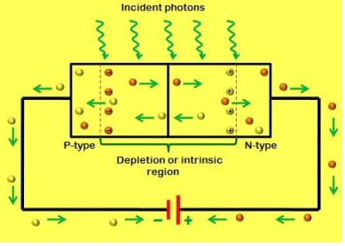

Application of Photodiode
- Photodiodes are used in simple day-to-day applications.
- Photodiodes are used in solar cell panels.
- Photodiodes are used in logic circuits.
- Photodiodes are used in the detection circuits.
- Photodiodes are used in safety electronics such as fire and smoke detectors
- Photodiodes are used in numerous medical applications.

3/ Tunnel Diode
A tunnel diode is a very heavily doped p-n junction diode. In the Tunnel Diode, electric current is due to the “Tunneling effect”. In a Tunnel diode electric current decreases as the applied voltage increases, and at high voltage, it works as an ordinary p-n junction diode.

Working principle of Tunnel diode
Width of the depletion region depends on the level of doping in semiconductor materials, If the doping level is high then the width of the depletion region is thin and if the doping level is low then width of depletion layer is more. In tunnel diode the width of the depletion region is very thin.
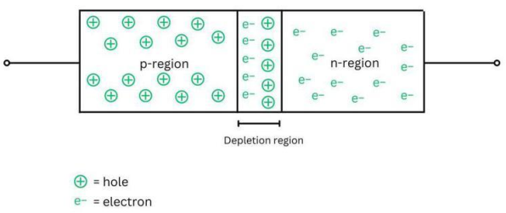

Application of tunnel diode
- Tunnel diode can be used as a switch, amplifier, and oscillator
- Tunnel diode acts as logic memory storage device.
- Since it shows a fast response, it is used as high frequency component.
- They are used in oscillator circuits, and in FM receivers.

4/ Zener diode
A Zener diode is a highly doped semiconductor device specifically designed to function in the reverse direction.
Working Principle of Zener Diode
The working principle is such that if the reverse bias voltage is less than the breakdown voltage, or if it is forward biased then it acts as an ordinary diode. Current in this region is known as avalanche current but for a Zener diode, it is also known as a Zener current.

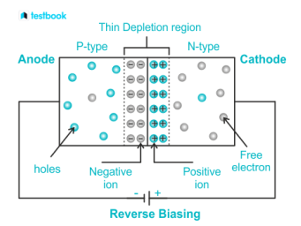

Application of Zener Diode
- Zener diode as a voltage regulator
- Zener diode in over-voltage protection
- Zener diode in clipping circuits

3rd Chapter
1/ Amplifying Actions of Transistor
A transistor is a semiconductor device used to amplify or switch electronic signals.

Amplifying Actions of Transistor
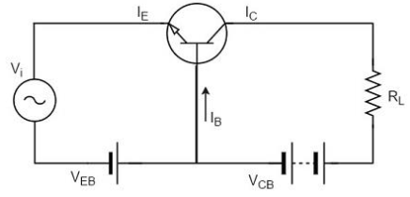
A transistor acts as an amplifier by raising the strength of a weak signal. The DC bias voltage applied to the emitter base junction, makes it remain in forward biased condition. The below figure shows how a transistor looks like when connected as an amplifier.

Thus, a small input voltage results in a large output voltage, which shows that the transistor works as an amplifier.

2/ Switching Actions of Transistor
A transistor is a semiconductor device that can amplify or switch electronic signals. When used as a switch, a transistor operates in one of two modes: cutoff or saturation.
In the cutoff mode, the transistor acts as an open switch, and no current flows through it. In the saturation mode, the transistor acts as a closed switch, and a large current can flow through it.
To use a transistor as a switch, it is connected in a specific configuration called a common-emitter configuration.
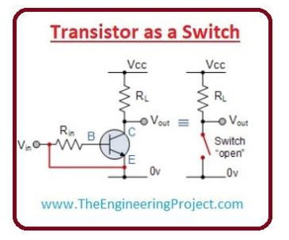

3/ Transistor Load Line Analysis
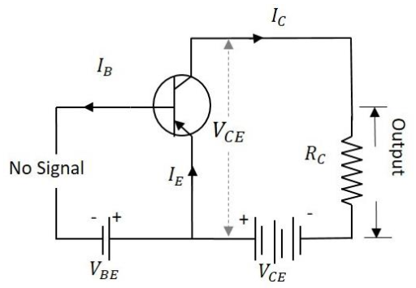
When the transistor is given the bias and no signal is applied at its input, the load line drawn at such condition, can be understood as DC condition. Here there will be no amplification as the signal is absent. The circuit will be as shown below.

The value of collector emitter voltage at any given time will be
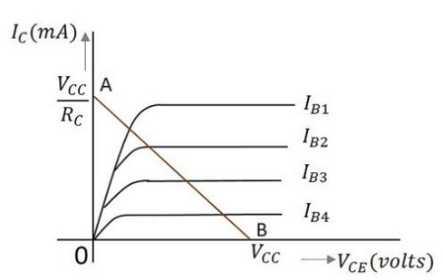
VCE=VCC-ICRC

To obtain A:

VCE=VCC-ICRC
0=VCC-ICRC
IC = 𝑉𝑐𝑐 / 𝑅 𝑐

To obtain B:

VCE=VCC-ICRC
VCE =VCC (As IC = 0)

Math Problem
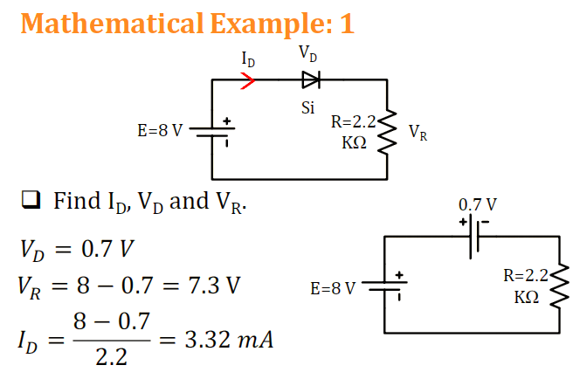

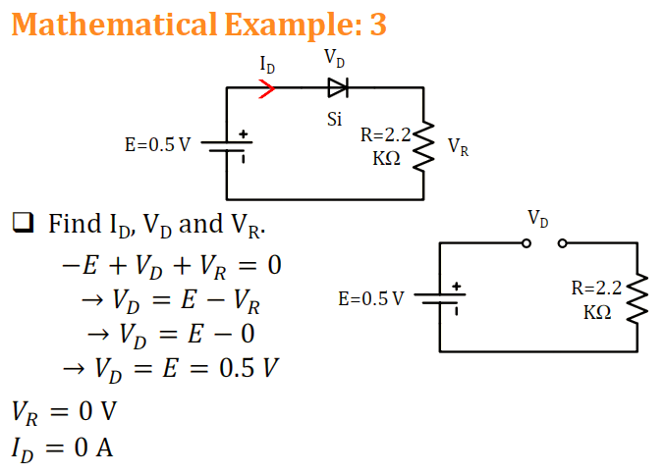
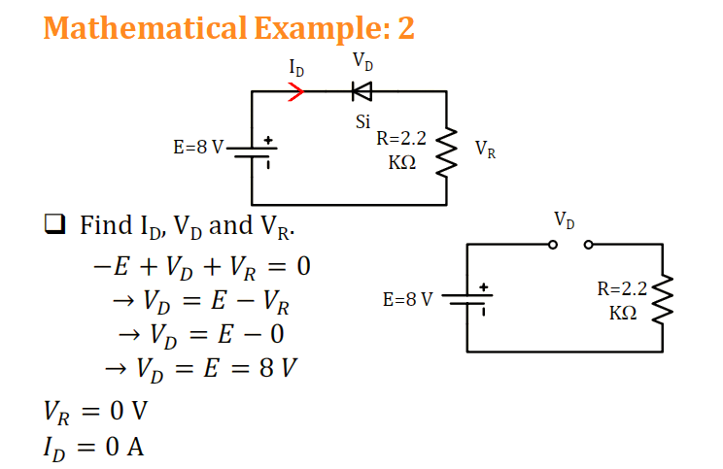

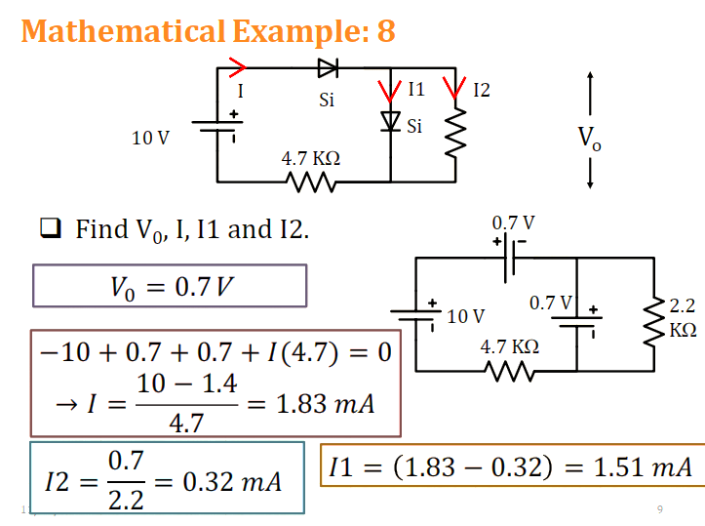
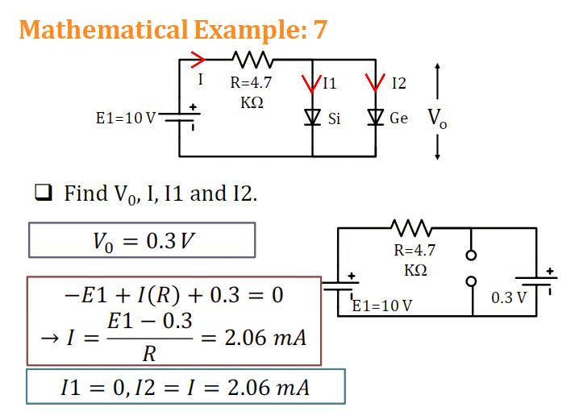
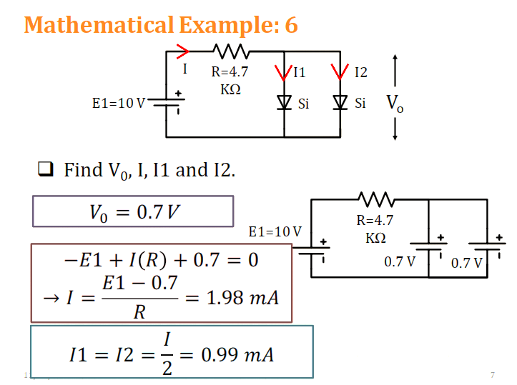

Final Topic
1. Define Field Effect Transistor (FET)
A field-effect transistor (FET) is a type of transistor that uses an electric field to control the current flow through a semiconductor channel.
Classification of FET
• Junction Field Effect Transistor (JFET)
• Metal oxide semiconductor Field Effect Transistor (MOSFET)
2. Define JFET and there Three Terminal of JFET.
Junction Field Effect Transistor (JFET) is one of the most basic forms of field-effect transistors.
Three terminals of JFET:
i. Source: The majority carriers enter the Field Effect transistor through the source terminal
ii. Gate: By controlling the Gate voltage, the flow of majority carriers from Source to drain can be controlled.
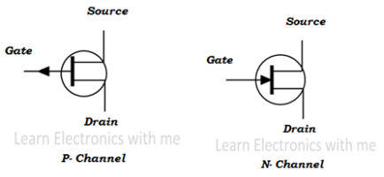
iii. Drain: The majority charge carriers leave the channel through drain. This current is designated by the source gate voltage VGS

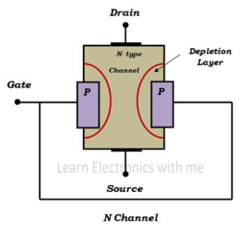

Junction Field Effect Transistor
3. Working for N Channel and P channel JFET with figure.

i. No get voltage –> resistance is low –> small voltage applied ->
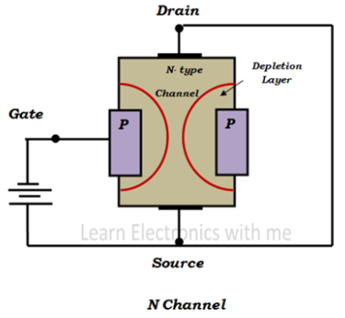
current to flow

ii. Negative source voltage –> depletion layer and resistance increase –>
controls the flow of current.

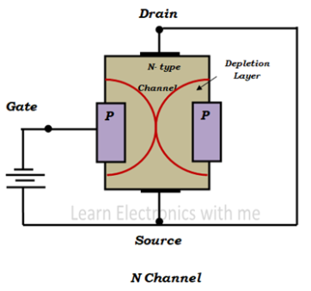

iii. Negative get source voltage increased –> depletion region increases – >
meet a point called pinch off Mode.

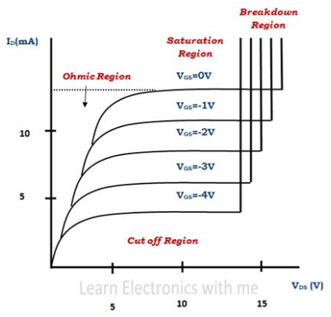
4. V – I characteristics of JFET with figure.
Ohmic Region: It is the region when gate source voltage is zero
VGS=0

Saturation Region: In this region JFET is ON and active.

Cut Off Region: JFET is OFF in this region and there is no drain
current flowing.

Metal Oxide Semiconductor Field-Effect Transistor (MOSFET)
5. Define MOSFET and there Three terminals of MOSFET.
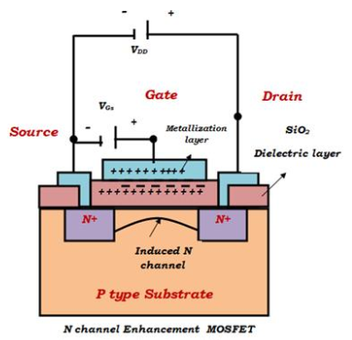
MOSFET stands for Metal Oxide Semiconductor Field Effect Transistor. It is a type of Field Effect Transistor and it is voltage-controlled device.
6. Working of Enhancement MOSFET with figure.
i. When gate voltage crosses minimum voltage.
ii. Turns on
iii. Current due to Majority carriers
iv. Source connected to negative terminal
v. Gate voltage increased
vi. Majority carriers become more than minority carrier.
vii. Overcome recombination.

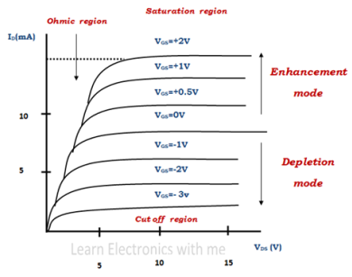
7. V – I characteristic of MOSFET with figure.
Ohmic region: Drain current increases when the drain source
voltage increases.
Cut off region: No current flows through it and the MOSFET is off.
Saturation region: Drain current is constant for drain source
voltage.
Mode : When negative voltage is applied to the gate terminal it
Operates in the depletion mode and when positive voltage applied
it Operates in the enhancement mode.

Triode for Alternating Current (TRIAC)
8. Define TRIAC and working principal of TRIAC with figure.
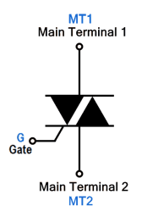
TRIAC stands for “Triode for Alternating Current”. Triode means a three - terminal device while AC means that it is used for switching Alternating current.
Working principle of TRIAC:
The operation of TRAIC resembles thyristor. When the voltage is applied, it will not
conduct unless the voltage. The TRAIC can operate in 4 modes.
Mode 1: MT1= +ve, Gate= +ve
Mode 2: MT1= +ve, Gate= -ve
Mode 3: MT1= -ve, Gate= +ve
Mode 4: MT1= -ve, Gate= -ve
Details:
Mode 1: MT1= +ve, Gate= +ve : In this mode, the applied voltage at MT1 is positive with respect to MT2. By applying a positive gate pulse. The TRAIC will trigger into forward conduction and the current will flow from MT1 to MT2

Mode 2: MT1= +ve, Gate= -ve : In this mode, the applied voltage at MT1 is positive with respect to MT2. By applying a negative gate pulse. it will trigger it into forward conduction while the current direction will remain the same.

Mode 3: MT1= -ve, Gate= +ve : In this mode, the applied voltage polarities are swapped i.e. MT1 is negative with respect to MT2. By applying a positive gate pulse. The gate pulse will trigger TRAIC into reverse conduction from MT2 to MT1.

Mode 4: MT1= -ve, Gate= -ve : In this mode, both the applied voltage and the gate voltage are negative. The negative gate pulse triggers the TRAIC into reverse conduction.

Diode for Alternating Current (DIAC)
9. Define DIAC and working principle of DIAC
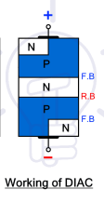
DIAC is an acronym that stands for “Diode for Alternating Current”. It is a two-terminal bidirectional switch. It cannot amplify or offer controlled switching.
Working principle of DIAC:
In order to trigger the DIAC into conduction, the applied voltage V must exceed break
over voltage VBO. When it happens, avalanche break down occurs at the reverse bias
junction and the current starts to flow through it.

Similarly, if the voltage polarities are swapped, the same process will repeat except
the current will flow in reverse direction. There is no difference in operation whatsoever if the polarities are swapped. The DIAC conducts current unless the current falls below the holding current limit.

10. Define Operational Amplifier.
An operational Amplifier is a three-dimensional device consisting of two high input impedance.

11. MIPS Registers
Add/ subtract/ load/ store/ branch on equal/ branch on not equal/ set on less than/ set on less than immediate/ jump.
Inverting Operational Amplifier
12. Inverting Operational Amplifier with figure and equation.
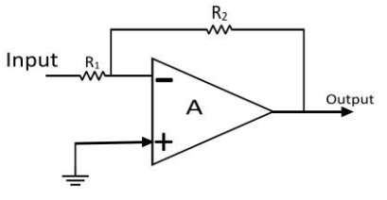
Input – negative – Inverting
Input – Positive – Non-Inverting
In the inverting operational amplifier circuit, the signal is applied at the
inverting input and the non-inverting input is connected to the ground.

Appling KCL at inverting node of Operational Amplifier,
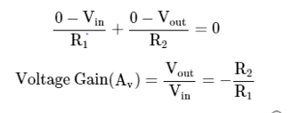

Non – Inverting Operational Amplifier
13. Non – Inverting Operational Amplifier with figure and equation.
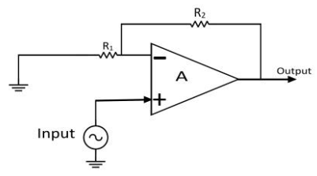
In the inverting operational amplifier circuit, the signal is applied at the
inverting input and the inverting input is connected to the ground.
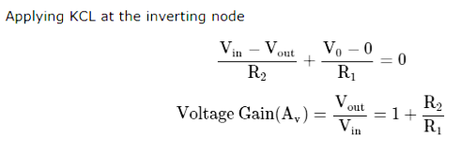

Integrators
14. Explain Integrators with figure and equation
An integrator is an electronic circuit that produces an output that is the integration of the applied input. An op-amp based integrator produces an output. The circuit diagram of an op-amp based integrator is shown in the following figure –

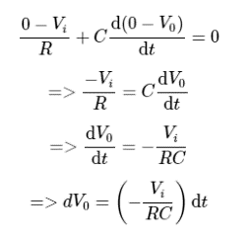
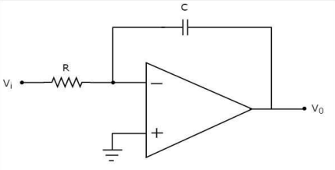
The nodal equation at the inverting input terminal is –

Summing Amplifiers
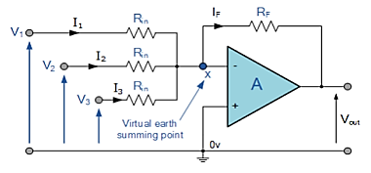
15. Explain Summing Amplifiers and with figure and equation.
In this simple summing amplifier circuit, the output
voltage, (Vout ) now becomes proportional to the sum
of the input voltages, V1 , V2 , V3 , etc.

Equation:
